Regulation of rRNA gene chromatin by histone chaperone-RNA (14 pt)

Mitsuru Okuwaki (12 pt)

Graduate School of Comprehensive Human Sciences, University of Tsukuba, 1-1-1 Tennodai, Tsukuba, 305-8577 Japan (12 pt)

Eukaryotic genome is packaged into chromatin consisting of core histones, H2A, H2B, H3, and H4. Regulation of the density of incorporated histone proteins around DNA transcription sites constitutes an important site-specific regulatory mechanism for the control of gene expression. Histone chaperones having the ability to associate with histones play crucial roles in the regulation of histone density. However, the targeting mechanism conferring this site specificity is not well understood. We previously identified B23/nucleophosmin as a factor regulating model chromatin template. We showed that B23 localizes at the nucleoli and associates with rRNA chromatin (r-chromatin) to stimulate rRNA transcription as a histone chaperone. ……….(12pt)

Dr. Mitsuru Okuwaki
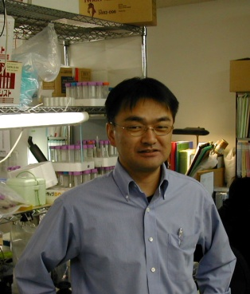
Associate Professor
Graduate School of Comprehensive Human Sciences and Promotion of Young Investigators’ Independent Research, University of Tsukuba, Japan
E-mail:mokuwaki@md.tsukuba.ac.jp

Brief CV
1999 Ph. D. Graduate School of Bioscience and Biotechnology, Tokyo Institute of Technology
1999-2002 Special Postdoctoral Researcher, RIKEN
2002-2003 Research Fellow, Cancer Research UK
2003-2007 Lecturer, Department of Basic Medical Sciences, University of Tsukuba
2007- Associate Professor, Graduate School of Comprehensive Human Sciences, University of Tsukuba

Selected Publications:
- Okuwaki M., Sumi A., Hisaoka, M., Saotome-Nakamura, A., Akashi, S., Nishimura, Y., and Nagata K. Nucleic Acids Res., 40(11):4864-78 (2012)
- Kato K., Okuwaki M., Nagata K. Involvement of Template Activating Factor-I as a chaperone in linker histone dynamics. J. Cell Sci., 93(Pt19): 3254-65 (2011)
- Hisaoka M., Ueshima S., Murano K., Nagata K., Okuwaki M. Regulation of nucleolar chromatin by B23/nucleophosmin jointly depends upon its RNA binding activity and transcription factor UBF. Mol. Cell Biol., 30(20): 4952-64 (2010) (Cover article)
- Okuwaki M., Kato K., and Nagata K. Functional characterization of human Nucleosome Assembly Protein 1-like proteins in human cells. Genes to Cells, 15(1): 13-27 (2010)
- Murano K, Okuwaki M., Hisaoka M, Nagata K. Transcription regulation of the rRNA gene by a multifunctional nucleolar protein, B23/nucleophosmin, through its histone chaperone activity. Mol. Cell Biol., 28(10):3114-26 (2008)

